Year 13 - LinkedIn
We recommend you have a LinkedIn profile whether you are entering the job market or going to university because:

1. LinkedIn Helps You Establish an Online Presence

2. LinkedIn Supplements (or Even Replaces) Your CV

3. You Can Use LinkedIn to Apply for Jobs

4. LinkedIn Lets You Research Prospective Employers

5. LinkedIn Helps You Connect with Alumni from The Misbourne and future education establishments
https://www.topuniversities.com/student-info/careers-advice/five-reasons-why-every-student-should-be-linkedin
https://collegeinfogeek.com/linkedin-summary-examples-for-students/

How to set yourself up
- Go to www.linkedin.com

- Click on [Join Now]
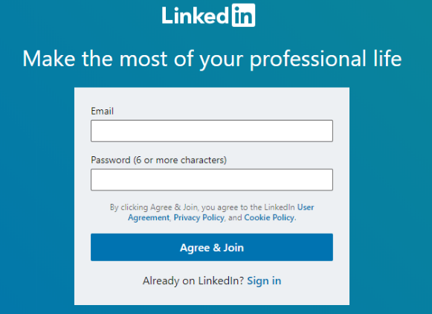
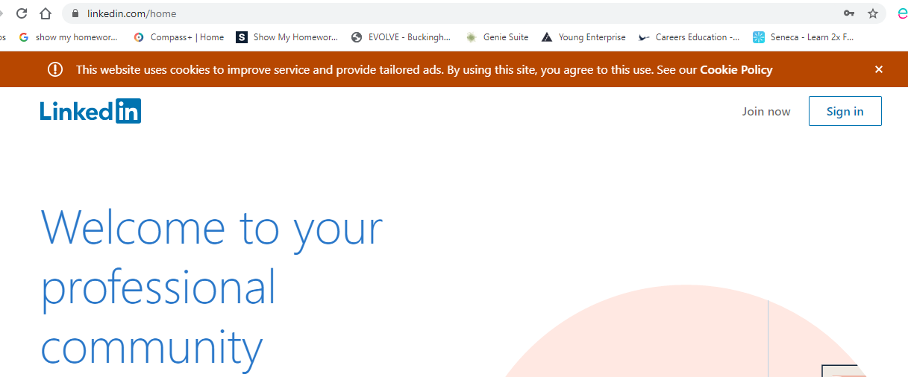

Enter your personal email address and create a password

LinkedIn profile
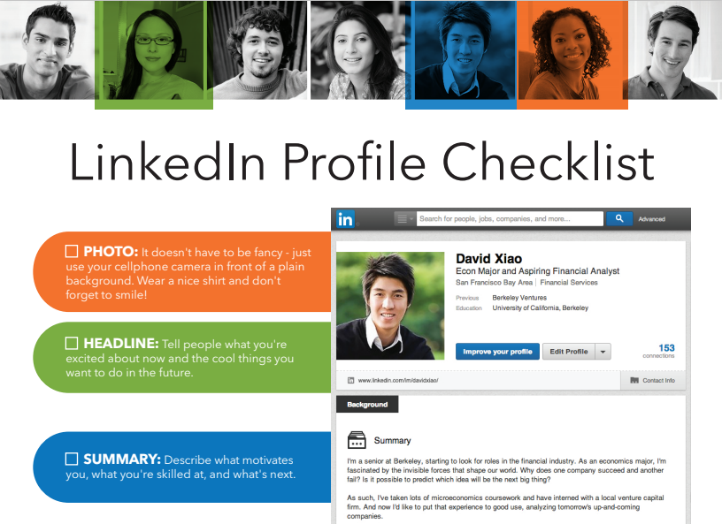
These hyperlinks will help you create a great profile
https://university.linkedin.com/content/dam/university/global/en_US/site/pdf/LinkedIn_Sample_Profile_onesheet-David.pdf
https://www.linkedin.com/help/linkedin/answer/112133/how-do-i-create-a-good-linkedin-profile-?lang=en

Manage your security settings
It is important that you follow the attached advice regarding your security settings : https://www.linkedin.com/help/linkedin/answer/66/managing-your-account-and-privacy-settings-overview?lang=en

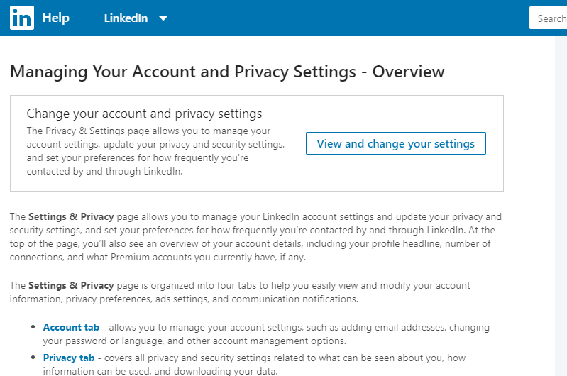
Link with The Misbourne
- In the Education section – start typing ‘The Misbourne’ and then select The Misbourne (rather than typing a slightly different format) and the Misbourne swans should appear. This will allow you to join the alumni.
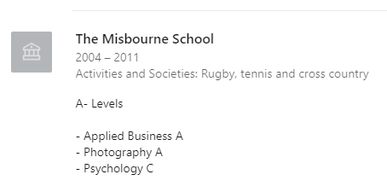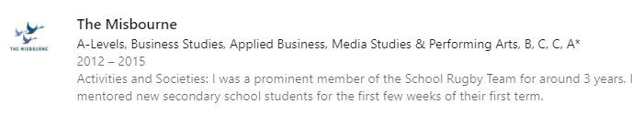
- Join The Misbourne Alumni & follow our news. This will enable you to keep in contact with the Class of 2020, your teachers and past students. Networking with past ‘Misbourners’ may help you when you are trying to arrange work experience / enter the job market.

- Click on ‘The Misbourne’ in your education section and it will take you to our page.
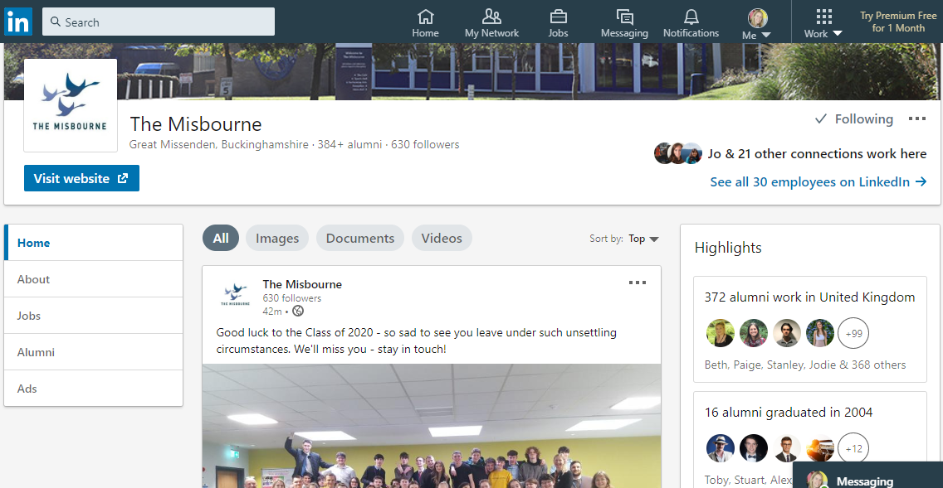
4. Click on [Alumni] and [Follow]

