Boss Your Future
Left school or college? Not working? Still unsure about your next step?
Boss Your Future is a brand-new traineeship for 16- to 24-year-olds looking to explore the world of work. If you’re not yet sure about your career goals we can provide support, inspiration and work experience opportunities to help you find a job, apprenticeship or training that’s right for you.

With our programme you’ll get:
- NCFE Level 1 Certificate in Occupational Studies.
- At least 70-100 hours of work experience that’s tailored to your interests.
- Support towards Functional Skills qualifications in English and maths.
- Support towards an Essential Digital Skills qualification.
- Support with CV writing and employability skills.
- Travel expenses reimbursed.

When does the course start?
Start date: Monday 14th February 2022.

Where is the course based?
Blended learning consisting of online sessions at home and classroom sessions based in our city centre office – Seetec, Graeme House, Derby Square, Liverpool, L2 7ZH

What qualification will I get?
Level 2 Certificate in Creating a Business Start-Up

Eligibility
16- 24 years old; Not currently employed or in education; Little or no work experience; Do not hold a qualification higher than a full level 3.

How long is the course?
This is an 8–12-week course, full-time from Monday-Friday 09:30-15:30 each day

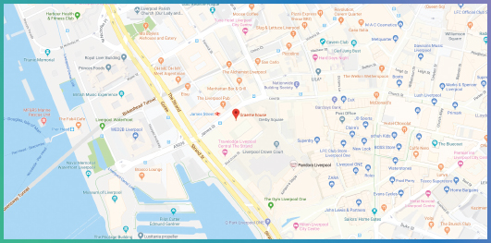
Can I still claim my benefits with the job centre?
Yes, benefits will not be affected, and regular communications and updates will be given to JCP.
Do you cover travel costs?
Yes, during the programme travel expenses will be reimbursed.
Do I have to pay to attend the programme?
There is no cost to the programme. It is fully funded.

Seetec, Graeme House, Derby Square, Liverpool, L2 9QR

Want to know more about the programme or book a place?
Please call or email:
Lynsey Gittoes 07732 691 696 / lynsey.gittoes@seetecoutsource.co.uk
Stuart Meredith: 0151 318 5656 / 07732 691643 / stuart.meredith@seetecoutsource.co.uk

