Entrepreneur Traineeship
Calling all budding entrepreneurs! Have you thought about starting your own business? Perhaps you’ve got an idea but you’re not sure where to begin?
With our brand-new Entrepreneur Traineeship, run in partnership with Merseyside Community Training, you’ll learn all about setting up and running your own business. You’ll get the chance to hear from successful entrepreneurs with hints and tips for starting out and inspirational stories to tell.

With our Entrepreneur Traineeship you’ll get:
- NCFE Level 2 Certificate in Creating a Business Start-Up.
- At least 70-100 hours working on a fundraising project to help build entrepreneurial skills.
- Support towards Functional Skills qualifications in English and maths.
- Support towards an Essential Digital Skills qualification.
- Support with CV writing and employability skills.
- Travel expenses reimbursed.

When does the course start?
Start date: Monday 10th January 2022 09:30

Where is the course based?
Blended learning consisting of online sessions at home and classroom sessions based in our city centre office – Seetec, Graeme House, Derby Square, Liverpool, L2 7ZH

What qualification will I get?
Level 2 Certificate in Creating a Business Start-Up

Eligibility
16- 24 years old; Not currently employed or in education; Little or no work experience; Do not hold a qualification higher than a full level 3.

How long is the course?
This is an 8-12 week course, full-time from Monday-Friday 09:30-15:30 each day

Can I still claim my benefits with the job centre?
Yes, benefits will not be affected, and regular communications and updates will be given to JCP.
Do you cover travel costs?
Yes, during the programme travel expenses will be reimbursed.
Do I have to pay to attend the programme?
There is no cost to the programme. It is fully funded.

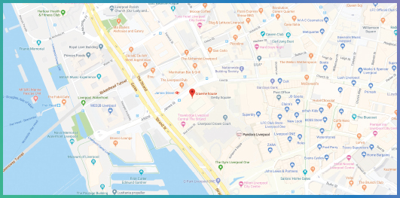
Want to know more about the programme or book a place?
Please call or email:
Gary Bennett: 0151 318 5656 / 07834 518598 / gary.bennett@seetec.co.uk
Stuart Meredith: 0151 318 5656 / 07732 691643 / stuart.meredith@seetecoutsource.co.uk

Seetec, Graeme House, Derby Square, Liverpool, L2 9QR

