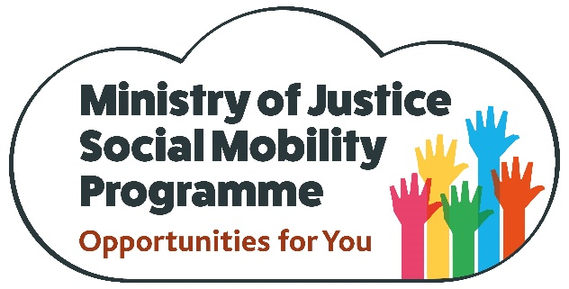

MoJ Schools Programme

The Ministry of Justice (MoJ) has developed a national schools outreach programme as part of its commitment to increase social mobility, available to all educational establishments with more than 20% eligibility for free school meals/within a lower socio-economic background demographic. MoJ is one of the largest Civil Service departments with responsibility for prisons, courts, probation, legal aid and justice policy. We also work in partnership with the other government departments and agencies to reform the criminal justice system, to serve the public and support the victims of crime.
Social Mobility Ambassadors visit schools, colleges and universities to run sessions with pupils to increase awareness, build confidence and potentially enhance the career aspirations of young people as they transition from school to employment. The programme is designed to target 14-24 year-olds, but sessions can be devised to appeal to students of all ages.
As well as increasing engagement and awareness, visits will also provide an opportunity to signpost potential entry points into the Civil Service such as apprenticeships, the Fast Stream and internships to ensure that these initiatives are promoted to young people from a diverse range of backgrounds.
Our volunteers can deliver a range of sessions to meet the specific needs of your school and your students. Suggested sessions include:
- Career journeys (Guest speakers will share their career journeys and lessons learned)
- Careers fairs (We will manage a stand at your school and highlight MoJ and CS careers available)
- Mock interviews (We will enhance skills in these areas for students)
- Speed networking (Chat about our roles with small groups and answer questions)
- You Be the Judge – (We will present an interactive, online simulation of the process and outcomes of the court system to aid understanding and facilitate debate)
To discuss your requirements and book an event, please contact the MoJ Social Mobility Team on socialmobility@justice.gov.uk

