Warehousing Academy
Do you want to work in warehousing and distribution? also gain your FLT Licence?

Gain a nationally recognised qualification, FLT licence and valuable work experience in 12 weeks! No previous experience or knowledge is required for you to start from age 16-24 years.

Course content includes:
- Develop Effective Working Relationships with Colleagues in Logistic Operations.
- Health, Safety and Security at Work
- Keep stock at required levels in logistics operations.
- Keep work areas clean in logistic operations.
- Moving and – or handling goods in logistic operations
- Operate equipment to perform work requirements in logistic operations.
- Pick goods in logistic operations
- Wrap and park goods in logistics operations.

Travel expenses will be reimbursed. Lunch is provided daily in the centre for each learner.

When does the course start?
Course start date soon.
Information days to be held every Friday in Liverpool City Centre Office.

Where is the course based?
Classroom based learning in our city centre office and 1 week for FLT Training, also 3 week block work experience with a great companies.
.
What qualification will I get?
Level 2 Certificate in Warehouse and Storage. You will also gain your Forklift Truck Licence.

Eligibility
To be eligible for this opportunity, you need to be 16-24 years old, not in education or employment, have little or no work experience and do not hold a qualification higher than a full Level 3.

Can I still claim my benefits with the job centre?
Yes, if on benefits, these will not be affected, and regular communications and updates will be given to JCP.
Do you cover travel costs?
Yes, during the programme travel expenses will be reimbursed.
Do I have to pay to attend the programme?
There is no cost to the programme. It is fully funded.

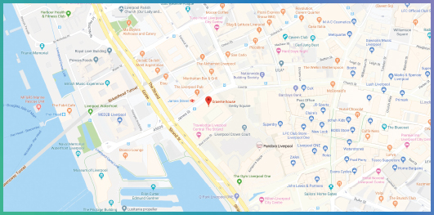
Want to know more about the programme or book a place?
Please call or email:
Lynsey Gittoes 0151 318 5656 / 07732 691 696 / lynsey.gittoes@seetecoutsource.co.uk

Seetec, Graeme House, Derby Square, Liverpool, L2 9QR

