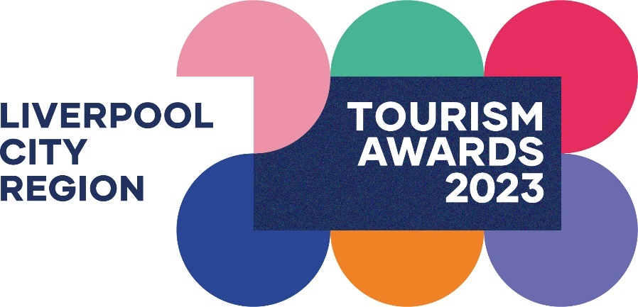

Eurovision Experience Award

Recognises any organisation that can demonstrate how they embraced the Eurovision Song Contest 2023 and offered all visitors a world beating Liverpool City Region experience, through the use of innovative and creative approaches, whilst embracing Ukraine and its culture, attracting new customers, and also learning, developing and improving from the whole process.

This sample application form is for information only and all applications must be made via the online application system.

Eligibility criteria

- This category is open to any organisation, within or relating to the Visitor Economy across Liverpool City Region. For example: Accommodation, Cultural Venues, Guided Tours, Hospitality & Catering, Retail, Transport, Visitor Attractions and other organisations who can successfully demonstrate how they embraced the Eurovision Song Contest to create an enhancing visitor experience and increase sales.

- Any organisation within Liverpool City Region actively involved in the Visitor Economy sector and who can clearly demonstrate how they are part of that wider Visitor Economy offering.

- Organisations of all sizes can apply as this category is judged within the context and style of the business.

- This category is purely focussed on activity taking place around the Eurovision Song Contest in May 2023.

- Organisations offering year-round ‘experiences’ may also apply for the ‘Experience of the Year’ category.

Applicant & Organisation details
(not scored)
Applicant’s name:
Enter the applicant’s name here.

Applicant’s job title:
Enter the applicant’s job title here.

Applicant’s phone number:
Enter the applicant’s phone number here.

Applicant’s email:
Enter applicant’s email here.

Organisation name:
Name of Organisation application relates to. Give the name used to promote the business, as you wish it to appear in all publicity materials, on certificates, in presentations etc.
Enter your Organisation name here.

Organisation address:
Enter your Organisation address here.

Closures during judging period (the judging period runs from 30th October 2023 – 26th January 2024):

Enter closures during the judging period here.

Promotional Description
Provide a promotional description of your business.
- Focus on its strengths and stand out features
- Write your description with regard to this category
- This wording will be used in PR and awards literature if you are short listed as a finalist
- Wording provided is subject to edit
- 120 word maximum

Enter the promotional description here.

Promotional Images
Provide up to three landscape high resolution photos.
- Photos should relate to this category
- Photos should not be edited in any way e.g. embedded text or logos, a collage
- Only include photos that you own the copyright for
- If the photo requires a third-party credit e.g. photographer, please provide details
- These photos will be used in PR and awards literature if you are short listed as a finalist

Number of staff employed/volunteers.
Please indicate approx. number of Full Time/Part-Time/Volunteers/additional volunteers recruited for Eurovision.

Approx. % of staff engaged with Eurovision activity and visitors to the city region.

Approx. budget spend on Eurovision activity. i.e., did you have any additional budget over and above your normal budget spend, for that period.
£

Did you receive any Eurovision Grant Funding, e.g., Liverpool City Council Euro Grant? Y/N

Online presence
Provide links to your online presence. e.g
- Links to any business pages/profiles on Facebook, Instagram, etc. and Twitter handles
- Provide specific links to customer review listings for your business e.g., TripAdvisor, Facebook, Booking.com, Google, Euan’s Guide, UpFront Reviews
Website
Enter the website URL here.
Social Media Platforms
Provide links to all your Organisation’s pages/profiles on Facebook, Instagram etc. and Twitter handles
Enter social media platforms here.
Online review sites
Provide specific links to customer review listings for your Organisation e.g. TripAdvisor, Booking.com, Google, Euan’s Guide, UpFront Reviews
Enter online review sites here.

Question 1 – Unique Experience
(This question is 25% of the final score)
Please state how the experience you offered was unique, creative and innovative so that visitors left with a highly positive and everlasting impression of the city and city region? (500 words)
Judges will look for:
- How you and your staff gave visitors ‘A truly Liverpool/Ukrainian experience’ which was unique to our city and city region.
- How you introduced and then demonstrated to visitors a new side to our city and city region.
- Examples of immersive and experiential engagement through animation and employee engagement.
- Your PR and Marketing reach.

Enter answer to question 1 here.

Links to relevant supporting evidence online (optional):

Question 2 - Growth
(This question is 25% of the final score)

Explain how you used the Eurovision Song Contest as a catalyst to grow your organisation during that period and deliver an outstanding experience/offer to visitors to the city region. (500 words)
Judges will look for:
- An increase in the number of customers during that period.
- Evidence of an % increase in sales/revenue during that period.
- How your staff were fully involved in the Eurovision Experience from start to finish.

Enter answer to question 2 here.

Links to relevant supporting evidence online (optional):

Question 3 – Embracing Ukraine
(This question is 25% of the final score)
How did your organisation embrace Ukraine in both your planning and delivery of your experience/activity from start to finish? (300 words)
Judges will look for:
- Evidence of engagement with Ukrainian businesses, artists, cultural organisations and other.
- How you have continued to incorporate Ukrainian culture into your organisation.

Enter answer to question 3 here.

Links to relevant supporting evidence online (optional):

Question 4 – Legacy
(This question is 25% of the final score)
Describe the legacy and the lessons you have learnt from Eurovision 2023 and how you will now look to embrace future events within the city region, in order to capitalise and maximise on those opportunities. (300 words)
Judges will look for:
- Examples of things you have learnt from your Eurovision 2023 Experience
- How you have made permanent changes to your Organisation in terms of:
- Future developments
- Your visitor offer/experience,
- Enhancing customer service levels/standards
- Other changes made post Eurovision
- Involvement in future LCR events
- What will you now do differently to ensure that all your visitors are always guaranteed a Warm Unique Liverpool Welcome?

Enter answer to question 4 here.

Links to relevant supporting evidence online (optional):

